|  |  |  |  |
| --- | --- | --- | --- |
| 1 | Name of project | Health Promotion/Preventive | |
| 2 | Background and write up | ***Start date***  2015 | **Donor/ Partners**  **Brot –** County Government of Siaya, Homabay, Vihiga, Kisumu (MOH), Local Administration, MOE, Kelin, NASCOP, EGPAF Foundation, CSA, TICH, Niiache Nikomae, LVCT, Standard Chartered Bank, Kisumu Cancer Centre |
| ***County/ sub county***  Siaya County – Alego Usonga and Bondo Sub counties  Homabay County – Rachunyo East, Rachuonyo North, Homabay Town, Rangwe Sub counties  Kisumu – Nyakach, Seme, Nyando, Kisumu West sub counties  Vihiga County – Sabatia Sub county | |
| 3 | Target | 6,000 thousand beneficiaries in Siaya, Kisumu, Homabay and Vihiga Counties | |
| 4 | Number of beneficiaries | 4,800 thousand beneficiaries reached | |
| 7 | Achievements | * Community sensitization on Covid 19 virus, distribution of face masks, liquid hand wash, hand wash containers, bar soaps, hand sanitizers and assorted food items during COVID 19 pandemic * Partnership with Danid Care Services in awareness and sensitization of non - communicable diseases * Support County Government (MOH) during World AIDS Day, World Toilet day amongst others * In collaboration with the NASCOP distribution of condoms | |

**Background Information**

Health Promotion and Disease Prevention is implemented in the Counties of Kisumu, Siaya, Homabay, Vihiga and Siaya. Objective is to promote the well-being of individuals and encourage healthy lifestyles, prevent disease, illness and injury, enable environments that support health and well-being and to reduce personal and social harm.

STIPA in collaboration with the Ministry of Health conduct health promotion and disease prevention sessions in the community in the areas where STIPA implements its projects.

Health issue is identified by the Health Facility, then STIPA organizes for health education sessions at the community either at the Chiefs’ barazzas, churches, schools or health facilities.

On other occasions this is normally done at the health facilities during clinic days or observed National Health Days like, Toilet and hand washing Day, World AIDS Day, amongst others.

**Strategies used in the implementation**

* ***Health Communication -*** Raising awareness about healthy behaviors for the general public through verbal and written strategies to influence and empower individuals, populations, and communities to make healthier choices. Examples of communication strategies include public service announcements, health fairs, mass media campaigns, and newsletters.
* ***Health Education -*** Empowering behavior change and actions through increased knowledge e.g. trainings.
* ***Community Outreaches –*** Reaching out to the community or providing services to a community who might not have access to such services, e.g. mobile clinic days.
* ***Dialogue Days -*** Interactive

**Photos Gallery**

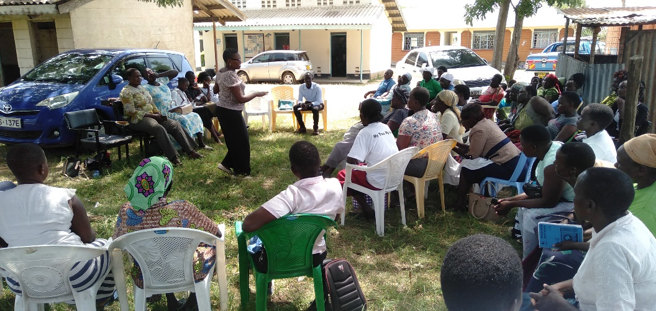

Figure ; STIPA staff sensitizing the community members about STIPA

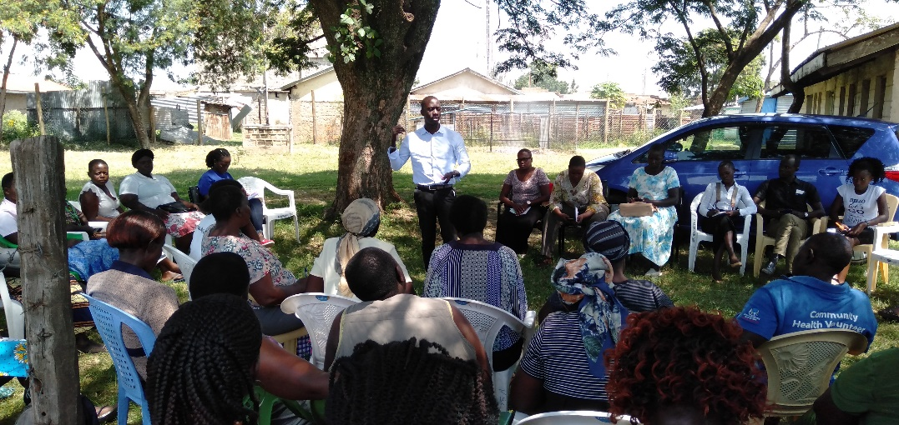

Figure :Danid Clinical Officer educating the community members about Cancer

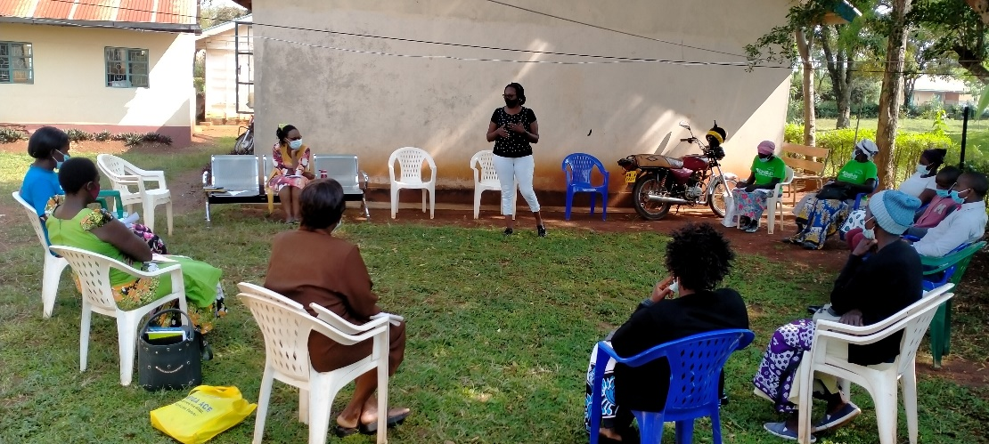

Figure : STIPA staff sharing with the CHVs about Covid 19 prevention

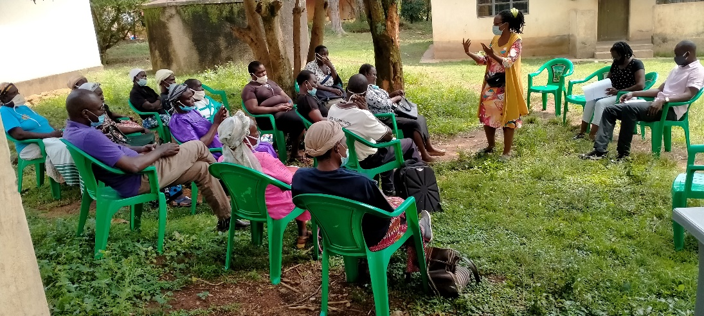

Figure : Maternal Child Health Technical Advisor taking the CHVs on the effects of Covd 19 to the community members